­­­­­

|  |  |
| --- | --- |
|  |  |



Solution Design

Document

Table of Contents

I. Purpose 3

II. Automated process details 4

2 Runtime guide 5

2.1 Architectural structure of the Master Project 5

2.2 Master Project Runtime Details 5

2.3 Loan Application Automation 6

2.4 Project(s) workflows 7

2.5 Packages 7

3 Glossary 8

# Purpose



The project for Loan Application Automation aims to streamline the process of handling loan applications from receipt to confirmation. This project consists of multiple sub-projects that collectively address various aspects of the loan application process, automating data processing, loan ID generation, communication, and integration with the bank's user interface. The automation project is designed to enhance operational efficiency, reduce human intervention, and improve the speed and accuracy of loan application handling. The focus of the Solution Architect will be on:

* Robustness;
* Scalability;
* Efficiency;
* Replicability;
* Reusability of component

The information herein is targeted primarily at the developers that will initially implement the solution and subsequently at the support developers in case of change requests.

# Automated process details

Details filled in need to reflect the actual information for the Master Project released for production. The following table will be populated:

|  |  |
| --- | --- |
| Item | Description |
| Master Project Name | Loan Application Automation |
| Robot Type | Attended |
| Orchestrator used? | Yes |
| Scalable | Yes |
| UiPath version used | 2025.0.166 |

# Runtime guide

## Architectural structure of the Master Project

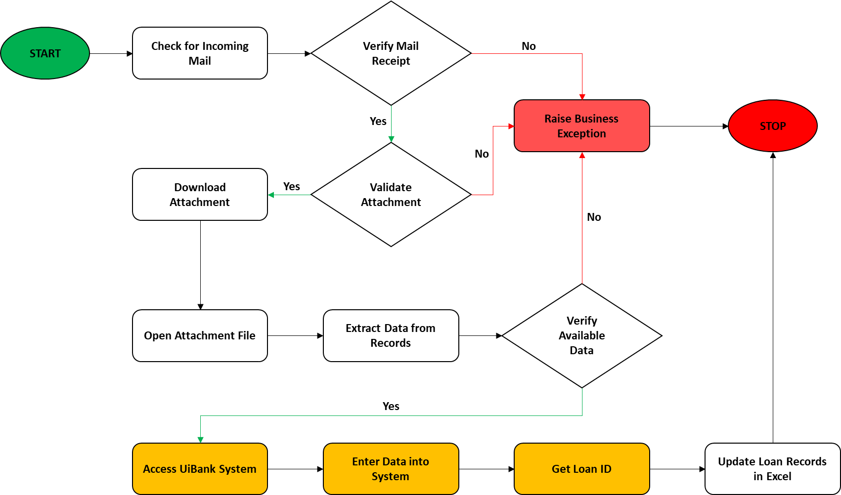

## Master Project Runtime Details

Outlines the details of the automated process by filling in the table below.

|  |  |
| --- | --- |
| ITEM NAME | DESCRIPTION  *Fill in each bolded section - empty fields are not allowed. If the section does not apply to your automation then mark as n/a.* |
| Production environment details | Running on a personal machine, and manual trigger for the process execution |
| Prerequisites to run | Loan application with email attachment received |
| Input Data | CSV files containing loan application data |
| Expected output | Loan application data processed, a unique Loan ID generated, recorded in Excel, and a confirmation email sent to the business team |
| How to start the automated process | Manually triggered through UiPath Orchestrator once the loan application data is available |
| Reporting  (queues reporting, Kibana or another platform) | Orchestrator logs and job dashboards for process monitoring, error handling, and performance tracking |
| How is Orchestrator used? | Used for manually triggering the process |
| Password policies  (mention any specific compliance requests) | N/A |
| Stored credentials  (Never use hardcoded credentials in the workflow!) | N/A |
| List of queues names  (Naming convention: ProcessName_QueueName) | N/A |
| Schedule Details | No scheduled trigger, process is manually triggered when required |
| Multiple Resolutions Supported?  (in case of image automation / Citrix and VDI) | N/A |
| Recommended Resolution | N/A |

## Loan Application Automation

|  |  |
| --- | --- |
| ITEM NAME | DESCRIPTION  *Fill in each section - empty fields are not allowed. If the section does not apply to your automation then mark as n/a.* |
| Environment used for development  (name, location, configuration details etc) | Personal machine (Windows 10) |
| Environment prerequisites  (OS details, libraries, required apps) | Windows 10, UiPath Studio, Microsoft Excel (for processing loan data), Email client (for receiving loan application emails) |
| Repository for project  (where is the developed project stored) | GitHub repository URL (https://github.com/Raxeira/loan-application-automation) |
| Configuration method  (assets, excel file, Json file) | Configured using an Excel file named Config.xlsx, which contains configuration details for the automation. |
| List of reused components | N/A |
|
| List of new reusable components | N/A |

## Project(s) workflows

Workflows specific to: Specify Project Name from section above

|  |  |
| --- | --- |
| Workflow Name | Description |
| **Main** | Invokes all the other workflows |
| **CloseAllApplications** | Closes all running applications |
| **GetTransactionData** | Retrieves transaction data |
| **InitAllApplications** | Initializes all applications |
| **InitAllSettings** | Initializes all settings |
| **KillAllProcesses** | Terminates all processes |
| **Process** | Main processing workflow |
| **RetryCurrentTransaction** | Retries the current transaction if needed |
| **SetTransactionStatus** | Sets the status of the current transaction |
| TakeScreenshot | Takes a screenshot of the current screen or process state |

## Packages

Include the list of packages and high-level description for each of them, to explain their purpose

|  |  |
| --- | --- |
| Package Name | Description |
| **UiPath.Excel.Activities = 3.0.1** | Provides activities for automating tasks in Excel, such as reading, writing, and manipulating data within Excel files. |
| **UiPath.Mail.Activities = 2.1.10-preview** | Contains activities for automating email-related tasks, such as sending, reading, and processing emails. |
| **UiPath.MicrosoftOffice365.Activities = 3.1.10-preview** | Provides activities for interacting with Microsoft Office 365 services like Outlook, OneDrive, and SharePoint. |
| **UiPath.System.Activities = 25.4.2** | Includes system-related activities for automation, such as file handling, process control, and data manipulation. |
| **UiPath.Testing.Activities = 25.4.0** | Used for automating test-related tasks, such as performing unit tests and validating workflows. |
| **UiPath.UIAutomation.Activities = 25.2.1-preview** | Contains activities for automating user interface tasks, such as clicking buttons, typing in text fields, and more. |

# Glossary

The main terms used in the Solution Architecture Document are defined below:

**Master project** - the overall output of the development, containing one or multiple projects that together cover the scope of the robotic process automation. There is a 1 to 1 connection between the Master Project and the Process to be automated (As presented in the PDD).

**Project** - an UiPath Studio project containing one or multiple workflow files. A project can be converted to a package and run independently, covering a particular scope within the master project. Or multiple projects can be converted into one package depending on the aims and restrictions of the automation. The project is used when defining the development and support phase of the automation.

**Package** - the output of compiling one or multiple projects. A package can be deployed on the robot machine and be executed by the robot service. Only one package can be executed at a given time by a robot. The package is used when defining the running phase of the automation.

Workflow - a component of the package, the workflow encapsulates a part of the project logic. The workflow can be of type: sequence, flowchart or state machine. A workflow is saved as an .xaml file inside the project folder. A workflow file can be invoked from another workflow and by default there is an initial workflow file that will run when executing the package.

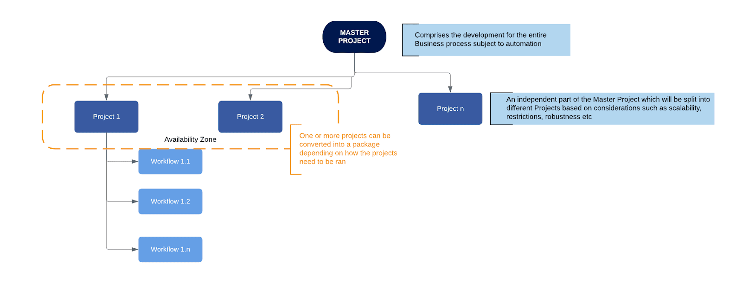

**Activity** - an action that the robot executes.

**Sequence** - a workflow where activities are executed one after another, in a sequential order

**Flowchart** - a workflow where activities are connected by arrows and the logic of the workflow can be easily followed in a visual manner. The flowchart can also be exported as an image from UiPath studio.

**State machine** - a more advanced way of organizing a workflow, similar to a flowchart.

**BOR** - Back office robot

**FOR** – Front office robot

**Orchestrator** – Enterprise architecture server platform supporting: release management, centralized logging, reporting, auditing and monitoring tools, remote control, centralized scheduling, queue/robot workload management, assets management.